# Workout Assistant: A Virtual Trainer Recommending Fitness Plans

## Abstract

The Workout Assistant is an intelligent virtual trainer that provides personalized fitness recommendations, progress tracking, and automated reminders. This system combines artificial intelligence, API connectivity, and mobile app support to maximize user engagement and motivation. By using AI models trained on user fitness data, the assistant adjusts workout plans in real time, optimizing performance and maintaining fitness goals.

## Introduction

With the increasing popularity of digital fitness solutions, users demand more personalized and adaptive workout plans. The Workout Assistant fills this gap by utilizing AI to suggest exercises, tracking user progress, and boost motivation with leaderboards and automated reminders. This project brings multiple technologies to provide an seamless and effective fitness coaching experience.

## 1. Utilizing Relevant Tools

* Flask: A lightweight Python framework for building RESTful APIs.
* Twilio: Enables SMS notifications for workout reminders.
* SMTP: Sends email notifications to users.
* Matplotlib: Used for visualizing workout progress.
* Threading: Automates periodic reminders to users.
* JSON: Stores and loads user profiles and fitness progress.
* Flutter (for Mobile App): Enables cross-platform mobile accessibility.
* TensorFlow/Keras: Provides AI-based recommendations for personalized fitness plans.

## 2. Fetching Relevant APIs

* Twilio API: Adds SMS-based reminders.
* Email SMTP API: Sends automated workout notifications.
* Flask REST API: Allows users to log progress and get workout plans.
* Google Firebase API: Stores user workout data and syncs across devices.
* AI Model API: Predicts suitable workout plans based on user fitness history.

## 3. Integration and Personalization

* Custom workout plans tailored to fitness level.
* AI-based workout recommendations.
* Progress tracking and leaderboard.
* Automated reminders (SMS, email, push notifications).
* Weekly progress summaries.
* Cross-platform mobile app support.

## 4. System Architecture

Below is a high-level architecture diagram illustrating how the system components interact:

+----------------+ +----------------+ +-----------------+  
| User Device | <-->| Flask Server | <-->| Twilio/SMTP API |  
| (Mobile/Web) | | (Backend Logic)| | (Notifications) |  
+----------------+ +----------------+ +-----------------+  
 | |  
 v v  
+----------------+ +----------------+  
| Progress DB | <-->| Leaderboard DB |  
+----------------+ +----------------+  
 | |  
 v v  
+------------------+ +-----------------+  
| Firebase Sync | <-->| AI Model Server |  
+------------------+ +-----------------+

## 5. Features Implemented

* Custom Workout Plans: Users can create and retrieve personalized plans.
* AI-Based Recommendations: The system suggests exercises based on user data.
* Progress Logging: Users can log workouts, including reps and sets.
* Leaderboard System: Users earn points for workouts and compete with others.
* Automated Reminders: SMS, email, and push notifications keep users engaged.
* Mobile App Support: Provides a seamless cross-platform experience.

## 6. AI-Based Workout Recommendation System

The AI module analyzes user workout history and fitness level to suggest personalized exercises. The recommendation model is trained using:

* User Profile Data: Age, weight, height, fitness goals.
* Past Workouts: Logged exercises, intensity, and frequency.
* Performance Metrics: Workout completion rate, improvement trends.

AI API Endpoint for Recommendations

Endpoint:  
POST /recommend_workout/<username>

Request Body:

{  
 "age": 25,  
 "weight": 70,  
 "fitness_goal": "muscle gain"  
}

Response:

{  
 "recommended_workout": ["Bench Press", "Squats", "Deadlifts"]  
}

## 7. Mobile App Wireframe

A simple Flutter-based mobile app UI can be designed with the following screens:

* Home Screen: Displays user workout stats and reminders.
* Workout Plan Screen: Shows recommended exercises and progress.
* AI Recommendations: Suggested workouts based on past performance.
* Leaderboard Screen: Displays rankings and user performance.
* Notification System: Push notifications for reminders.

## 8. Simulation and Testing

1. Start the Flask Server: Run the Python script to launch the API.
2. Set a Custom Plan: Submit a workout plan using the API.
3. Receive AI Recommendations: Retrieve personalized exercise plans.
4. Log Progress: Record workout details and track improvement.
5. Retrieve Leaderboard: View rankings based on total workout points.
6. Receive Reminders: Check SMS, email, and push notifications.
7. Test the Mobile App: Use the Flutter app to interact with the API.

## 9. Future Enhancements

* Real-time Heart Rate Monitoring: Integrate with wearables to track heart rate.
* Voice-Assisted Training: AI-powered voice coaching for better user interaction.
* Augmented Reality (AR) Workouts: Provide interactive workout demonstrations.
* Nutritional Guidance: AI-based diet suggestions based on workout performance.

## 10. Conclusion

The Workout Assistant effectively fills the gap between digital fitness tracking and personalized coaching. With the use of AI, APIs, and automation, it provides a highly engaging and adaptive experience for fitness enthusiasts. Future enhancements, such as real-time health monitoring and AR-based guidance, will further make the system more efficient and user friendly.

## 11. References

* TensorFlow: https://www.tensorflow.org/
* Flask Framework: https://flask.palletsprojects.com/
* Twilio API Documentation: https://www.twilio.com/docs/sms
* Firebase Documentation: <https://firebase.google.com/docs>

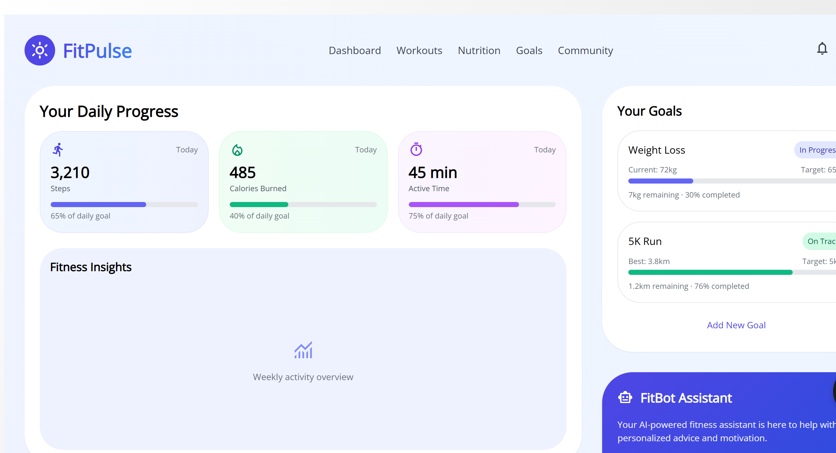

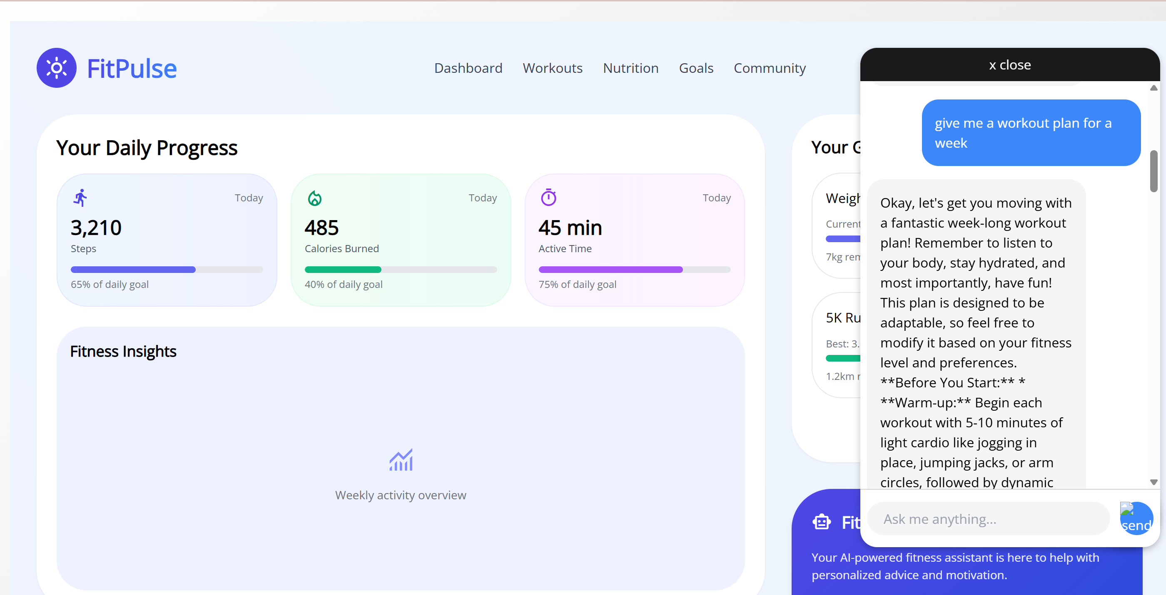

**GITHUB LINK**: <https://github.com/dinakaran-1/AI-Fitness-Chatbot>